IIUI Future Leaders" Training Program 3rd & 4th February 2025

The IIUI Future Leaders training program was initiated under the directives of the Worthy President and guidance of the Vice President (Research & Enterprise). The program aims to empower and develop emerging leaders within university. This program is tailored for faculty members focusing on enhancing their leadership and management capabilities to foster sustainable change and institutional growth.
The second phase of the program will commence on 3rd February 2025. The program will focus on the following key areas:
• Sustainability
• Administrative and Leadership Skills
• Educational Management & Operational Governance
• Quality Enhancement and Innovation in Research
• Conventional Professional Development
This initiative reflects the university’s commitment to empowering its faculty and ensuring excellence in all academic and administrative spheres.
Resource Persons

Prof. Dr. Syed Habib Bokhari  Vice Chancellor  Murree University | 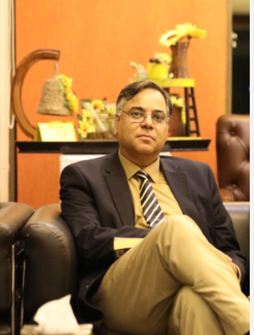
Dr. Noor Amna Malik  Managing Director  National Academy of Higher Education (NAHE)  HEC Islamabad | 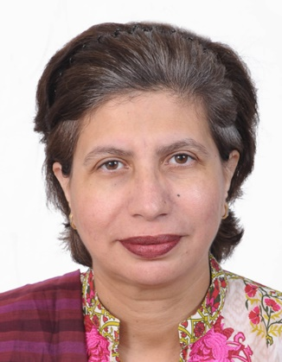
Prof. Tahir Mahmood Chaudhry  Executive Director, Hazza Institute of Technology,  President & CEO Pakistan Institute of Entrepreneurship | 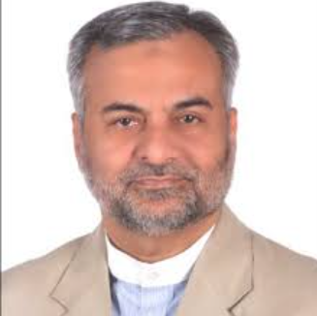
Mr. Shahid Minhas  Advisor Centre for Learning and Development (CLD) | 
Dr. Farrukh Idrees  Director QEC.  National Defense University | 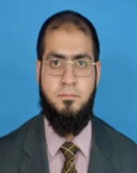
Sustainable Development Policy Institute
Dr. Farrukh Idrees

IIUI FUTURE LEADERS" TRAINING PROGRAM 3RD & 4TH FEBRUARY 2025
The International Islamic University Islamabad (IIUI) is proud to announce the second phase of its esteemed "IIUI Future Leaders" training program, scheduled to take place on the 3rd and 4th of February, 2025. Under the directives of the Worthy President and the guidance of the Vice President (Research & Enterprise), the program is designed to enhance the leadership and management skills of the university's faculty members, promoting sustainable institutional growth and fostering excellence.
This phase of the program will focus on five key areas:
- Sustainability
- Administrative and Leadership Skills
- Educational Management & Operational Governance
- Quality Enhancement and Innovation in Research
- Conventional Professional Development
Resource Persons and Trainers
The training sessions will feature renowned experts and distinguished speakers. Their names, accompanied by their titles, are as follows:
- Prof. Dr. Syed Habib Bokhari
Vice Chancellor, Murree University
- Dr. Noor Amna Malik
Managing Director, National Academy of Higher Education (NAHE), HEC Islamabad
- Prof. Tahir Mahmood Chaudhry
Executive Director, Hazza Institute of Technology
President & CEO, Pakistan Institute of Entrepreneurship
- Mr. Shahid Minhas
Advisor, Centre for Learning and Development (CLD), Sustainable Development Policy Institute
- Dr. Farrukh Idrees
Director, QEC, National Defense University
The IIUI community is encouraged to actively participate and make the most of this transformative opportunity aimed at equipping leaders for the future.

