**IIUI DELEGATION VISITS FAMILY OF LATE MUHAMMAD TUFAIL**

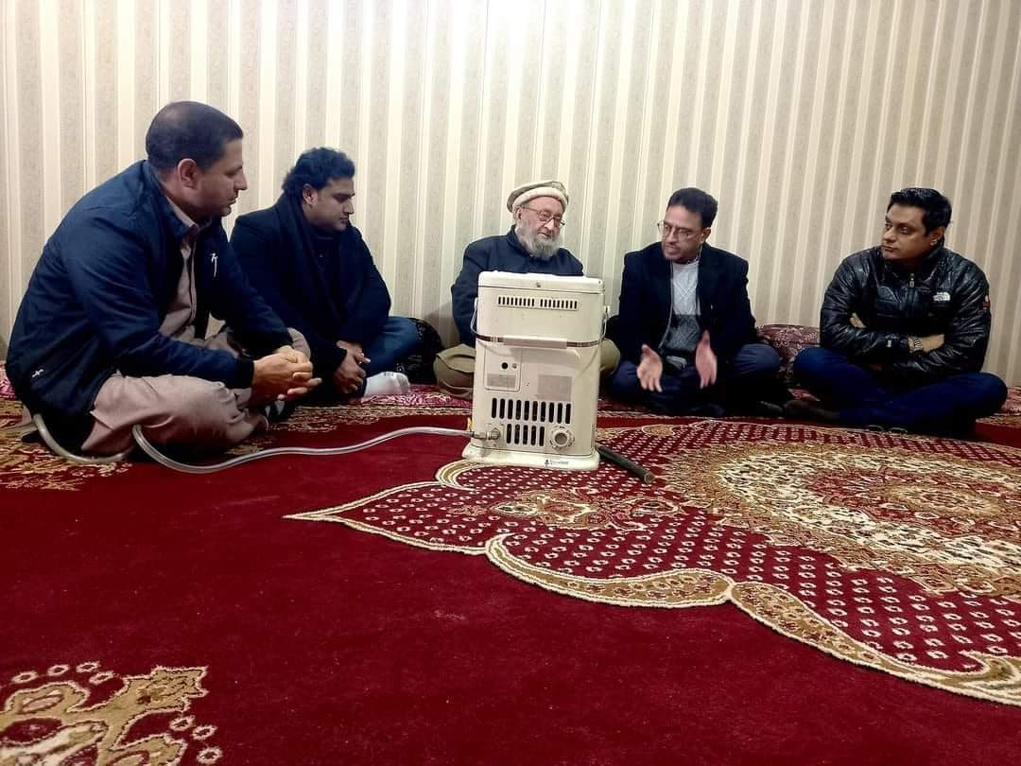A delegation of the International Islamic University, Islamabad (IIUI) visited the family of the deceased university student Syed Muhammad Tufail.

The delegation was headed by the Vice President Academics Prof. Dr. Ayaz Afsar and it met with the father and brother of late Muhammad Tufail at Gilgat at their native city. The delegation members included Students Advisor Dr. Tauqeer Hussain Sargana, Incharge P&PR Nasir Farid and Deputy Director P&S, Muhammad Nasir.

Delegation members conveyed the condolences on the behalf of the IIUI President H.E. Dr. Hathal Homoud Alotaibi who had expressed grief on the irreparable loss of the late Muhammad Tufail. Prof. Dr. Ayaz Afsar told that the IIUI President, since his joining had desired that a university delegation must visit Gilgit for the condolence but the global pandemic caused hiatus due to lockdowns. The delegation intended to visit the grave of late Muhammad Tufail but it was conveyed by the family and locals that due to heavy snowfall it was not possible to travel towards the graveyard.

Father of Muhammad Tufail thanked IIUI President for condolence and also thanked the university delegation for the visit.